Hi Sunny –

I’m really liking the new format… thank you for implementing it – I think it looks great! I appreciate you taking the time to do so. I have a few adjustments I’ve outlined below but they are mostly small enhancements.

Transition after clicking “See the Cyclical Strength Index” –

Right now, when clicking the button, the site transitions to the Current CSI section immediately. I’m wondering if it’s possible to implement the same transition style as the buttons on the navigation bar. For example, when clicking Proof Points, the site scrolls down the point of the site were the anchor is located. Can the same type of transition be implemented when clicking on See the Cyclical Strength Index?

New GIF –

I’ve created some higher quality versions of the GIF. Do you mind swapping out the version from yesterday with the new version? I’ve included two… one with a transparent background and the other with the same dark gray background as the current site. I suppose it doesn’t matter which is used.

Mobile Format –

Can the responsiveness settings of the site be configured so that the mobile layout resembles the below (essentially, the same approximate layout as squeezemetrics). (please see the below screenshot)

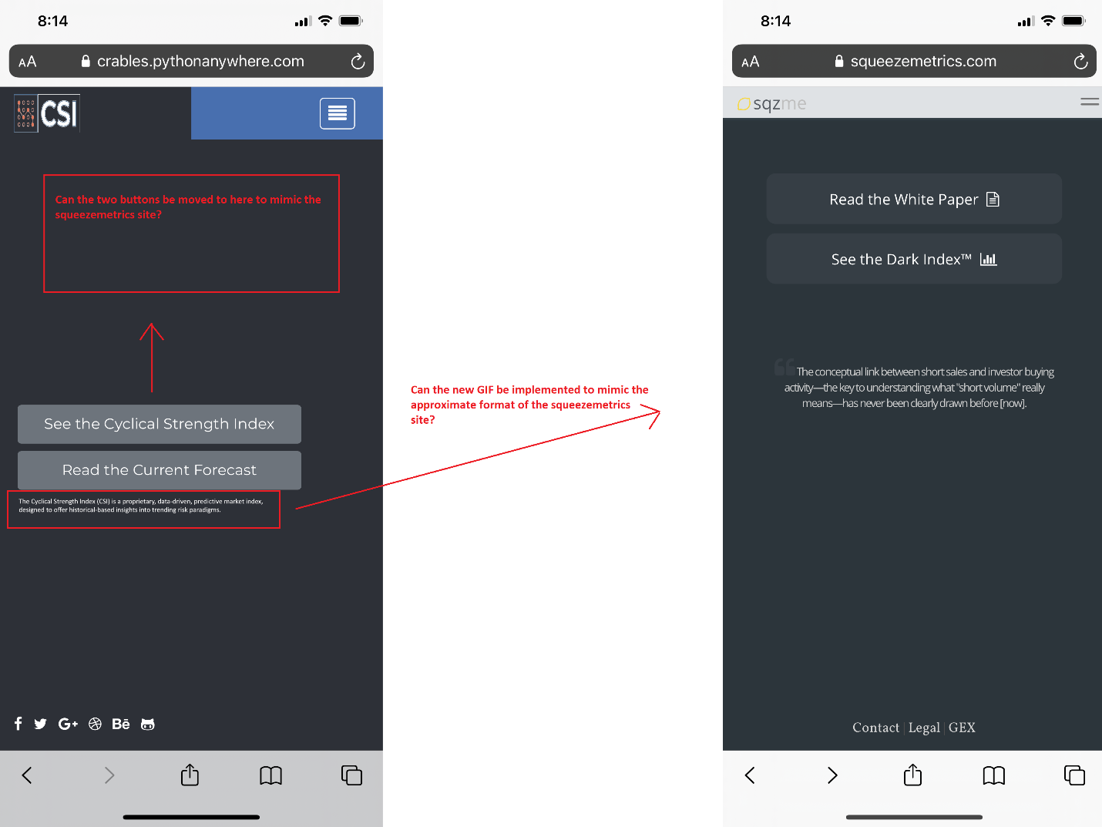

Button background color –

Do you mind if we make the following two adjustments to the buttons? I’m unsure if the first one is possible, but figured I would ask…

1 – Is it possible to make the buttons a little bit more round? I’m not sure if that’s a setting that can actually be adjusted, but I wanted to check if so.

2 – Can the color of gray used as the background for the buttons be a little darker please? The color corresponding to hex: #363e45 I think will look nice. But after implementing, we can always adjust a little more need be.